Revision sheet on integers

Question 1
In a kitchen, some food is stored at −18°C in a freezer and some at 4°C in the fridge. A roast is cooking in the oven at a temperature of 180°C.
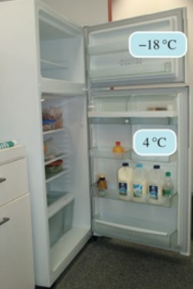
Before answering each of the following questions, draw a number line to show the positions of the temperatures.
a) What is the difference in temperature between the food stored in the freezer and the food stored in the fridge?
(Hint: Difference = largest value − smallest value)

b) What is the difference in temperature between the food stored in the fridge and the roast cooking in the oven?

c) What is the difference in temperature between the food stored in the freezer and the roast cooking in the oven?

Question 2
The following is a homework sheet done by a student in Year 7. Correct her work for her and give her a mark out of six. Make sure you include the correct answer if her answer is wrong.
- −3 + −7 = −10
- −4 − −10 = −6
- −7 − 8 = 15
- 70 + (-180) = 110
- 42 + 7 − −11 = 60

Question 3

Complete the following (use your number line) :
- -5 - 2 = __________

- - 8 - 3 = __________

  - 2 - 3 = __________

  - -12 + 11 = __________

Question 4

Susan had $48 in the bank. She wants to buy a pair of shoes for $65. How much extra does she need?

